1. Install Nodexl template[1]
   1. Go to <http://nodexl.codeplex.com>
   2. Click “Downloads” tab and select the recommended version (tutorial creating using build 1.0.1.245)
   3. Unzip the package and run setup.exe. Follow the directions to install the template
2. Get data in edgelist format to use in NodeXL
   1. Open mesaedge.csv in Excel (you need to have [downloaded](https://github.com/ndporter/snademo/blob/master/mesaedge.csv) this or [produced it in R](https://github.com/ndporter/snademo/blob/master/MesaExport.R))
   2. Select cells B2:C204. This is a list of all the friendships in Faux Mesa. Copy it to the clipboard.

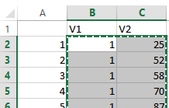

1. Open the NodeXL Template (“NodeXLGraph.xltx” in the NodeXL installation folder) in a new Excel window. It should open to the “Edges” worksheet. Put the cursor on the first cell under “Vertex 1” and paste your data from the clipboard.

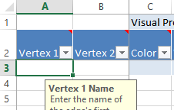

1. Create a first graph of the network structure:
   1. In the graph pane at the right, click the layout method arrow (the small arrow immediately to the right of the words “Fruchterman-Reingold”

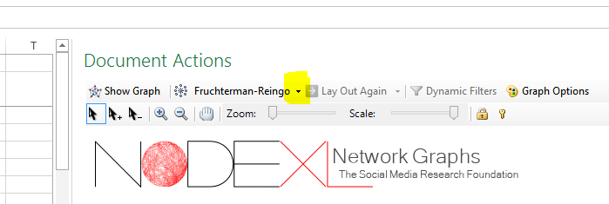

* 1. Select the “Harel-Koren Fast Multiscale option, then click “Show Graph” to the left to create the graph. It will look similar to the picture below but may be rotated. Note there are no isolates. This is because NodeXL utilizes edgelists. It is possible to add isolates to the vertices sheet manually, but we will not here.  
     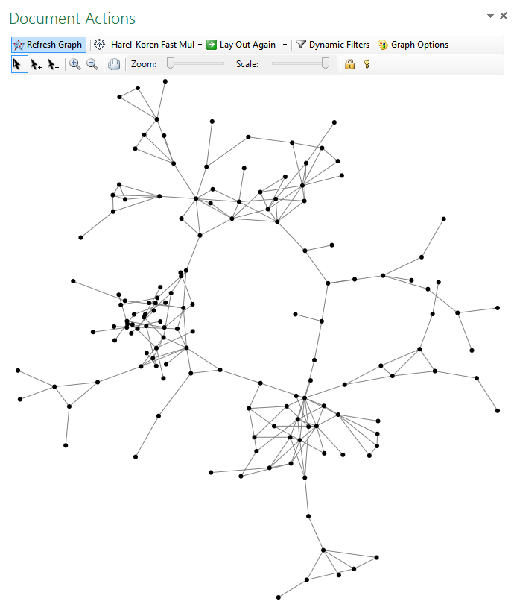

1. Leave the graph for now and return to the main spreadsheet pane. Click the NodeXL menu in the Ribbon and click the “Graph Metrics” button to bring up a menu:  
   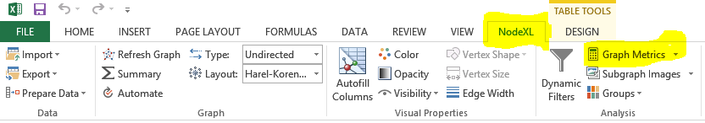  
   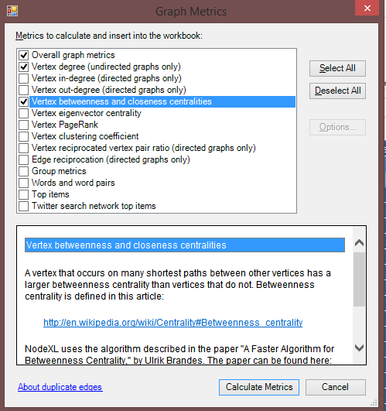
2. Select “Overall graph metrics, Vertex degree, and Vertex betweenness and closeness”, then click “Calculate Metrics” at the bottom.
3. After a moment for processing, NodeXL will show you the overall metrics tab. You can see there are 203 edges (friendships) and 11 components (connected groups) total, along with a number of other metrics and charts.  
   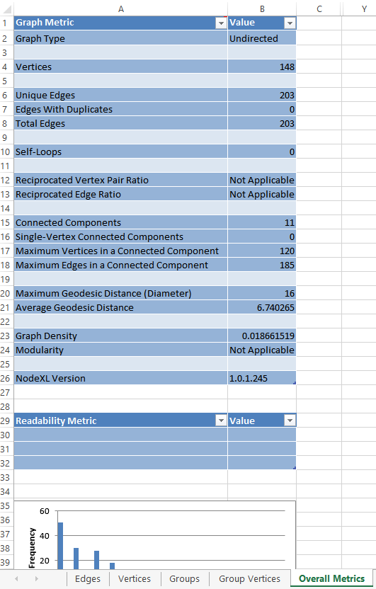
4. For now, open the “Vertices” sheet and take a look. Each vertex (person) is listed on the left by its ID number and your person-level centrality measures are to the right under the “Graph Metrics” section. You can click the arrow at the top of any column (Degree, Betweenness, etc.) to sort the sheet by values in that column or temporarily hide certain values.  
   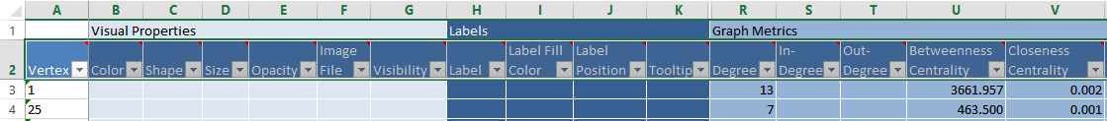
5. Adding attributes (non-network information) to NodeXL can sometimes be complicated. You need to sort the “Vertex” column in “Vertices” in ascending order (use the arrow) and sort the mesaatt.csv sheet the same way in Excel. Both sheets must have the same number of vertices (if there are any isolates in the original data, NodeXL may not match) and you must ensure that if the IDs are numbers, they are being treated as Text in both. This is easiest if the network data has non-numeric identifiers. For now, we move on to NodeXL’s most powerful and intuitive feature: visualization.
6. Since we have a number of centrality measures, we can now use the “Autofill Columns” feature (NodeXL ribbon - Visual Properties) to add more information to our graph. We may want to ensure for a start that the layout of nodes remains the same and only the shape/size/color change. To do so, select “None” in the layout box you previously set to “Harel-Koren”  
   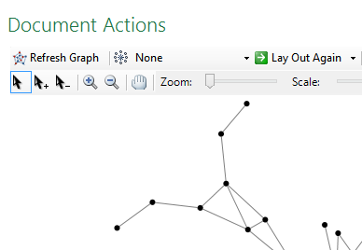
7. When you click on autofill columns, the menu below appears:  
   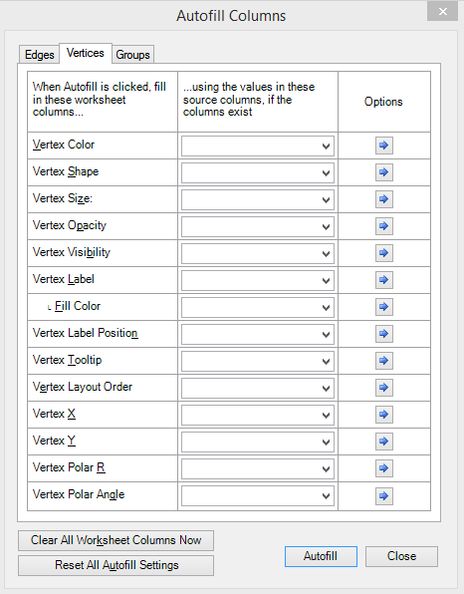  
   Go ahead and set the color to use Betweenness and click the right arrow in the options column. 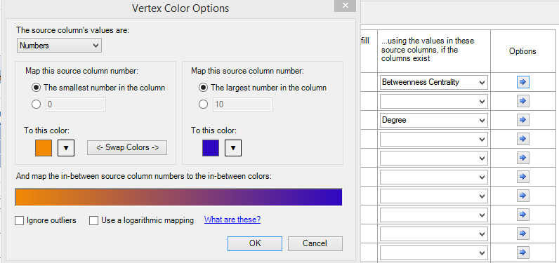  
    You’ll see that not only can NodeXL use discrete colors, it can also shade nodes on a color differential scale, which can produce nice visual effects. Leave the color options at default, except make sure to click “Ignore Outliers” at the bottom. Both this and the logarithmic mapping option help improve interpretability of skewed distributions. Also set size to degree; you can look at the options but leave them at default for now. Click “Autofill” then “Close” and take a look at how your graph has changed.  
   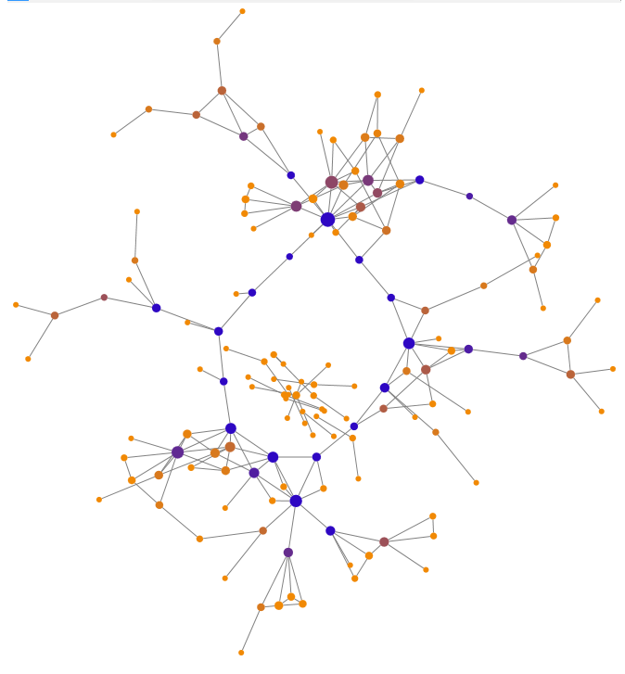  
   While the central circle-like chains are all blue, denoting high betweenness, they have varying numbers of connections to other nodes. Nodes can also be grouped either by clustering algorithms or node attributes using the “Analysis-Groups” function and subsequently visually clustered based on those groupings. Clicking on any node highlights it in red and, if the option is selected, highlights its ties.
8. You can save your work like any other spreadsheet. Settings will be kept but graphs will need to be re-generated if you quit NodeXL and restore your file later (and they may not be exactly alike). Images can be saved by right clicking and either copying to the clipboard or saving as any number of image file types (PNG, JPG, BMP).

In summary:

* NodeXL requires Windows and Microsoft Excel but is free
* NodeXL uses Edgelist data and is capable of scaling to large numbers of cases and potentially supporting attribute information also
* NodeXL’s clustering algorithms work quickly and visual settings are fairly intuitive and appealing
* Options, however, are limited and data structure may pose a challenge

1. NodeXL is a free template for Windows versions of Excel 2007-2013. It does not run natively or in Wine on a Mac at this time. It may be possible to run in an emulator such as VMWare Fusion.